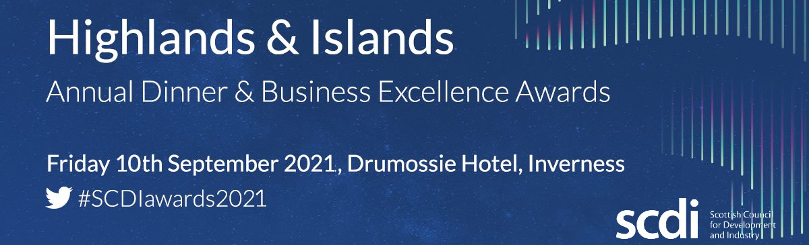
The SCDI Highlands and Islands Annual Dinner & Business Excellence Awards are a highlight in the Highland business calendar, attracting 350 guests from across the business and economic community.

There are a range of strategic partnership and profile raising opportunities available. For further information on the opportunities to showcase your business please contact Fiona Downie fiona.downie@scdi.org.uk
BOOKING FORM

£1,200 plus vat: Table (seating 10 guests)

Table |  |  | £1,200 plus vat
MAIN CONTACT DETAILS
Title: Forename: Surname:

Position:

Organisation:

Email:

Address:

Postcode:

PAYMENT
Please send an invoice: | Yes No or Credit Card Payment: Yes No
Is a purchase order needed? | Yes No PO Number:

For further information or to book for the Annual Dinner & Business Excellence Awards 2021 please contact us. E: fiona.downie@scdi.org.uk T: 01224 263380

