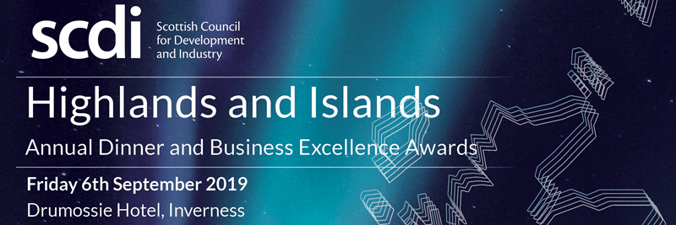

HIGHLANDS AND ISLANDS ANNUAL DINNER & BUSINESS EXCELLENCE AWARDS
FRIDAY 6 SEPTEMBER 2019
THE DRUMOSSIE HOTEL, INVERNESS

The SCDI Highlands and Islands Annual Dinner & Business Excellence Awards is a highlight in the Highland business calendar attended by 350 guests drawn from across the business and economic community.

The dinner provides a unique platform to showcase the achievements of the region's companies and is the key event for the recognition and celebration of excellence in a wide range of sectors.

Established over 13 years ago the awards are free to enter and open to any business or organisation that can demonstrate excellence in the relevant category. Over the year’s we’ve seen some outstanding achievements recognised.

About SCDI

SCDI is Scotland's social and economic forum. SCDI's aim is to influence and inspire government and key stakeholders to create sustainable economic prosperity for Scotland, an ambition as relevant today as it was when SCDI was established in 1931.

SCDI's influential membership includes businesses, trade unions, local authorities, educational institutions, the voluntary sector and faith groups. This unique gathering of knowledge, experience and talent provides a dynamic and creative force for change.

SCDI opened its Inverness office in 1965 with the aim of supporting a strong and vibrant economy for the Highlands & Islands and is committed to the growth and development of the region.

www.scdi.org.uk | @SCDInews

CROWN ESTATE AWARD FOR EXCELLENCE IN A MARINE BUSINESS

The award will be presented to the marine business, working in the Highlands and Islands, which can best demonstrate successful working in the region’s marine environment. This should be supported by evidence of business performance, environmental care and sustainability, and may also include local community involvement.

APPLICANT’S DETAILS
Name:
Position:
Full Company Name:
Address:
Main Telephone Number:
Direct Telephone Number:
E-mail:
Website:
Nature of Business:
Year Established:
Number of Employees in the Highlands and Islands:
Total number of Employees:

- Please give a brief overview of why your company should be considered to receive the Award (maximum 350 words). Please give details of performance or any specific projects or programmes which are outstanding in your sector.

2. Please provide evidence of how you plan to achieve the growth potential of your business and meet the opportunities and challenges for your business going forward.

TO THE APPLICANT

The deadline for entries is Thursday 1 August 2019.

Please complete and return this form to:

H&I Awards
Scottish Council for Development and Industry
21b Kingsmills Road
Inverness IV2 3JX

T. 01463 231878
E. inverness.office@scdi.org.uk

The winner will receive two complimentary tickets for the Awards Dinner.

Disclaimer:
Information provided as part of an award application will be shared with the award category sponsor and those judging the category. Contact and other details provided will be used solely for the purposes of assessing the award application and communication in relation to it.

